**Enterprise Application Development   
BSCS - YELLOW (BATCH-18)**



**SUBMITTED BY:**

**Adi Afzaal (18101002-033)**

**DEPARTMENT: COMPUTER SCIENCE**

**PROGRAM: BSCS-18**

**SUBMITTED TO: Sir Fahad**

**DATE: 1, Nov, 2021.**

**UNIVERSITY OF SIALKOT**

**Main Activity**

**Code:**

*activity_main.xml*

**<?**xml version="1.0" encoding="utf-8"**?>**

<LinearLayout

xmlns:android="http://schemas.android.com/apk/res/android"

xmlns:tools="http://schemas.android.com/tools"

android:layout_width="match_parent"

android:layout_height="match_parent"

android:gravity="center"

android:orientation="vertical"

android:padding="16dp"

tools:context=".MainActivity">

<Button

android:id="@+id/btnDialogBox"

android:layout_width="match_parent"

android:layout_height="wrap_content"

android:text="Dialog box" />

<Button

android:id="@+id/btnToastDemo1"

android:layout_width="match_parent"

android:layout_height="wrap_content"

android:text="Toast Demo 1" />

<Button

android:id="@+id/btnToastDemo2"

android:layout_width="match_parent"

android:layout_height="wrap_content"

android:text="Toast Demo 2" />

</LinearLayout>

*MainActivity.java*

**public** **class** **MainActivity** **extends** **AppCompatActivity** {

Button btnDialogBox;

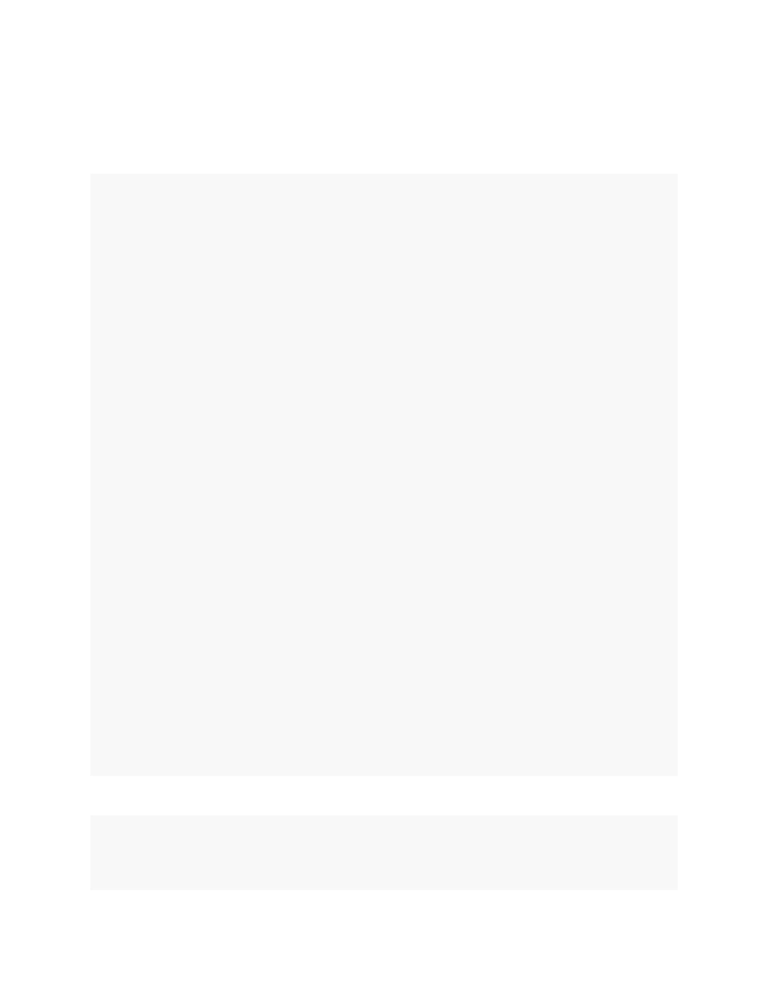

Button btnToastDemo1;

Button btnToastDemo2;

**@Override**

**protected** **void** **onCreate**(Bundle savedInstanceState) {

**super**.onCreate(savedInstanceState);

setContentView(R.layout.activity_main);

btnDialogBox = findViewById(R.id.btnDialogBox);

btnToastDemo1 = findViewById(R.id.btnToastDemo1);

btnToastDemo2 = findViewById(R.id.btnToastDemo2);

btnDialogBox.setOnClickListener(v -> {

Intent intent = **new** Intent(MainActivity.**this**,

AndDemoUI1.class);

startActivity(intent);

});

btnToastDemo1.setOnClickListener(v -> {

Intent intent = **new** Intent(MainActivity.**this**,

ToastDemo1.class);

startActivity(intent);

});

btnToastDemo2.setOnClickListener(v -> {

Intent intent = **new** Intent(MainActivity.**this**,

ToastDemo2.class);

startActivity(intent);

});

}

}

**Screenshot:**

**Dialoge Box Activity**

**Code:**

*activity_and_demo_ui1.xml*

**<?**xml version="1.0" encoding="utf-8"**?>**

<LinearLayout

xmlns:android="http://schemas.android.com/apk/res/android"

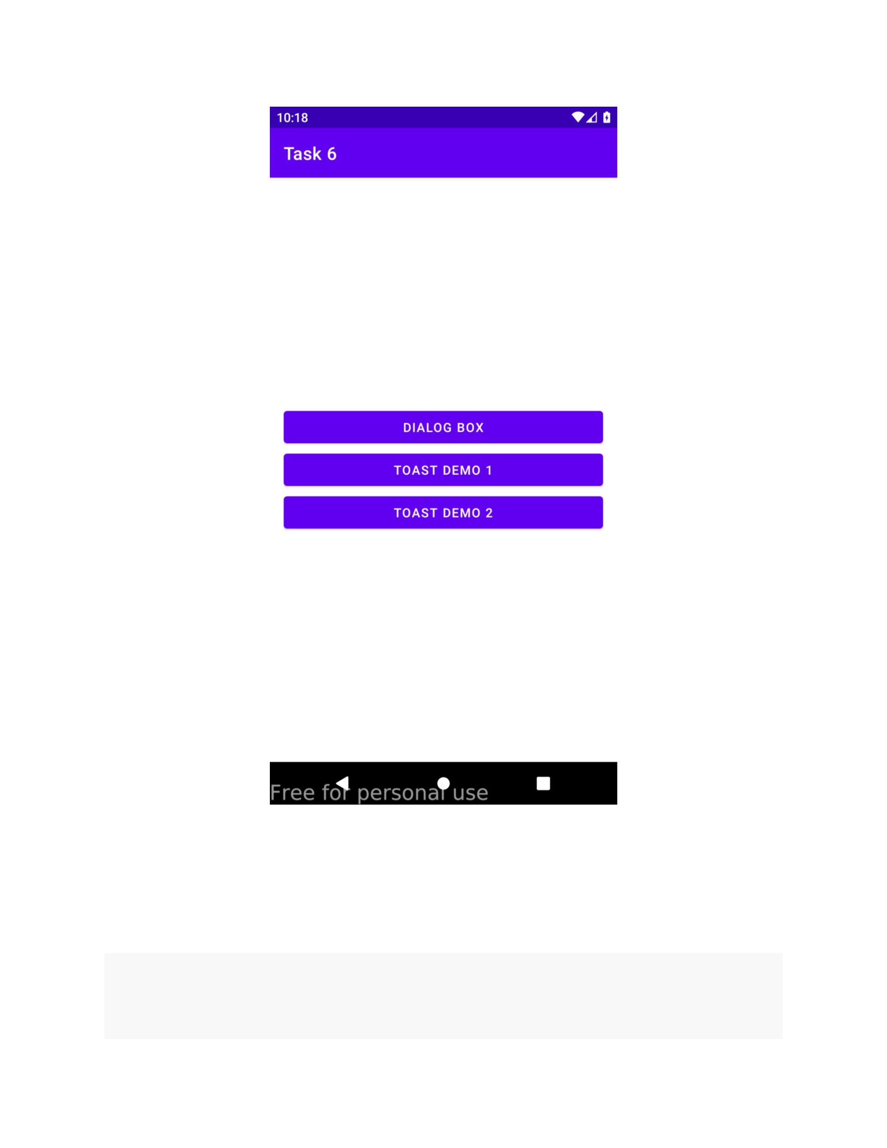

android:id="@+id/LinearLayout01"

android:layout_width="match_parent"

android:layout_height="match_parent"

android:orientation="horizontal">

<Button

android:id="@+id/btnGo"

android:layout_width="wrap_content"

android:layout_height="wrap_content"

android:text="GO" />

<EditText

android:id="@+id/txtMsg"

android:layout_width="fill_parent"

android:layout_height="wrap_content"

android:hint="click the button" />

</LinearLayout>

*AndDemoUI1.java*

public class AndDemoUI1 extends AppCompatActivity {

Button btnGo;

EditText txtMsg;

String msg;

@Override

protected void onCreate(Bundle savedInstanceState) {

super.onCreate(savedInstanceState);

setContentView(R.layout.activity_and_demo_ui1);

txtMsg = (EditText) findViewById(R.id.txtMsg);

btnGo = (Button) findViewById(R.id.btnGo);

btnGo.setOnClickListener(new View.OnClickListener() {

@Override

public void onClick(View arg0) {

AlertDialog dialBox = createDialogBox();

dialBox.show();

txtMsg.setText("I am here! ");

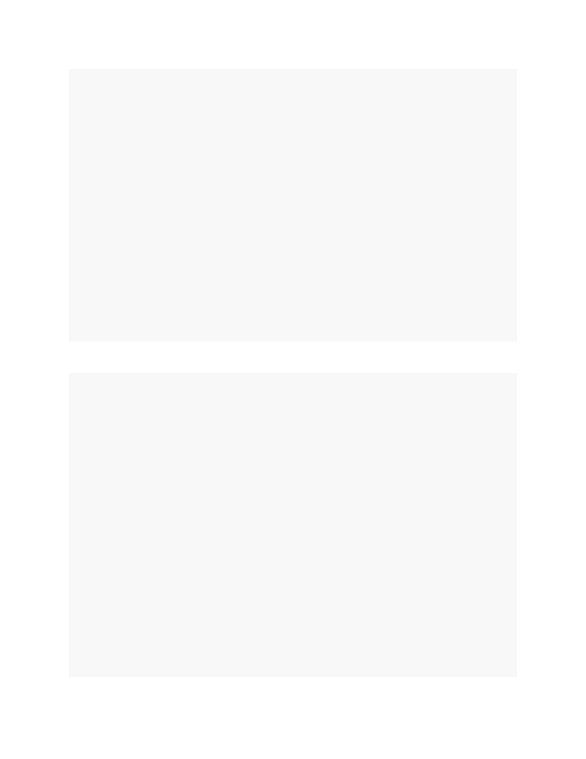

}

});

}

private AlertDialog createDialogBox() {

AlertDialog myQuittingDialogBox =

new AlertDialog.Builder(this)

.setTitle("Terminator")

.setMessage("Are you sure that you want to

quit?")

.setIcon(R.drawable.ic_menu_end_conversation)

.setPositiveButton("Yes", new

DialogInterface.OnClickListener() {

public void onClick(DialogInterface

dialog, int whichButton) {

msg = "YES " +

Integer.toString(whichButton);

txtMsg.setText(msg);

}

})//setPositiveButton

.setNeutralButton("Cancel", new

DialogInterface.OnClickListener() {

public void onClick(DialogInterface

dialog, int whichButton) {

msg = "CANCEL " +

Integer.toString(whichButton);

txtMsg.setText(msg);

}//OnClick

})//setNeutralButton

.setNegativeButton("NO", new

DialogInterface.OnClickListener() {

public void onClick(DialogInterface

msg = "NO " +

dialog, int whichButton) {

Integer.toString(whichButton);

txtMsg.setText(msg);

}

})//setNegativeButton

.create();

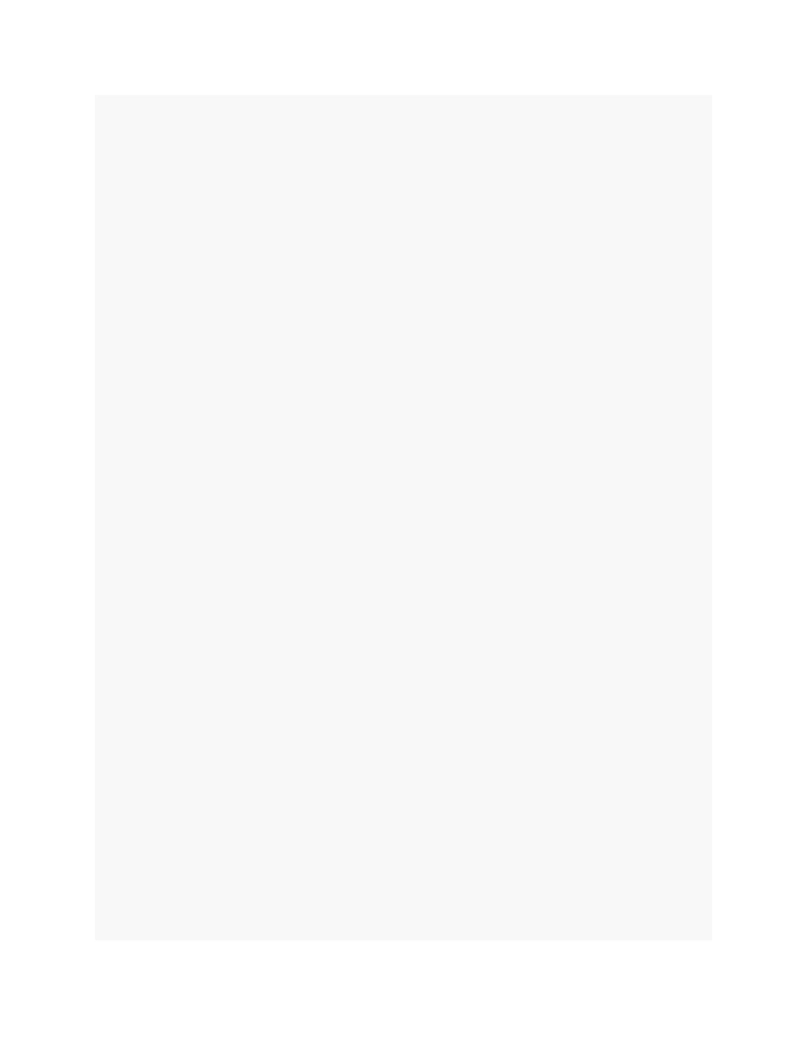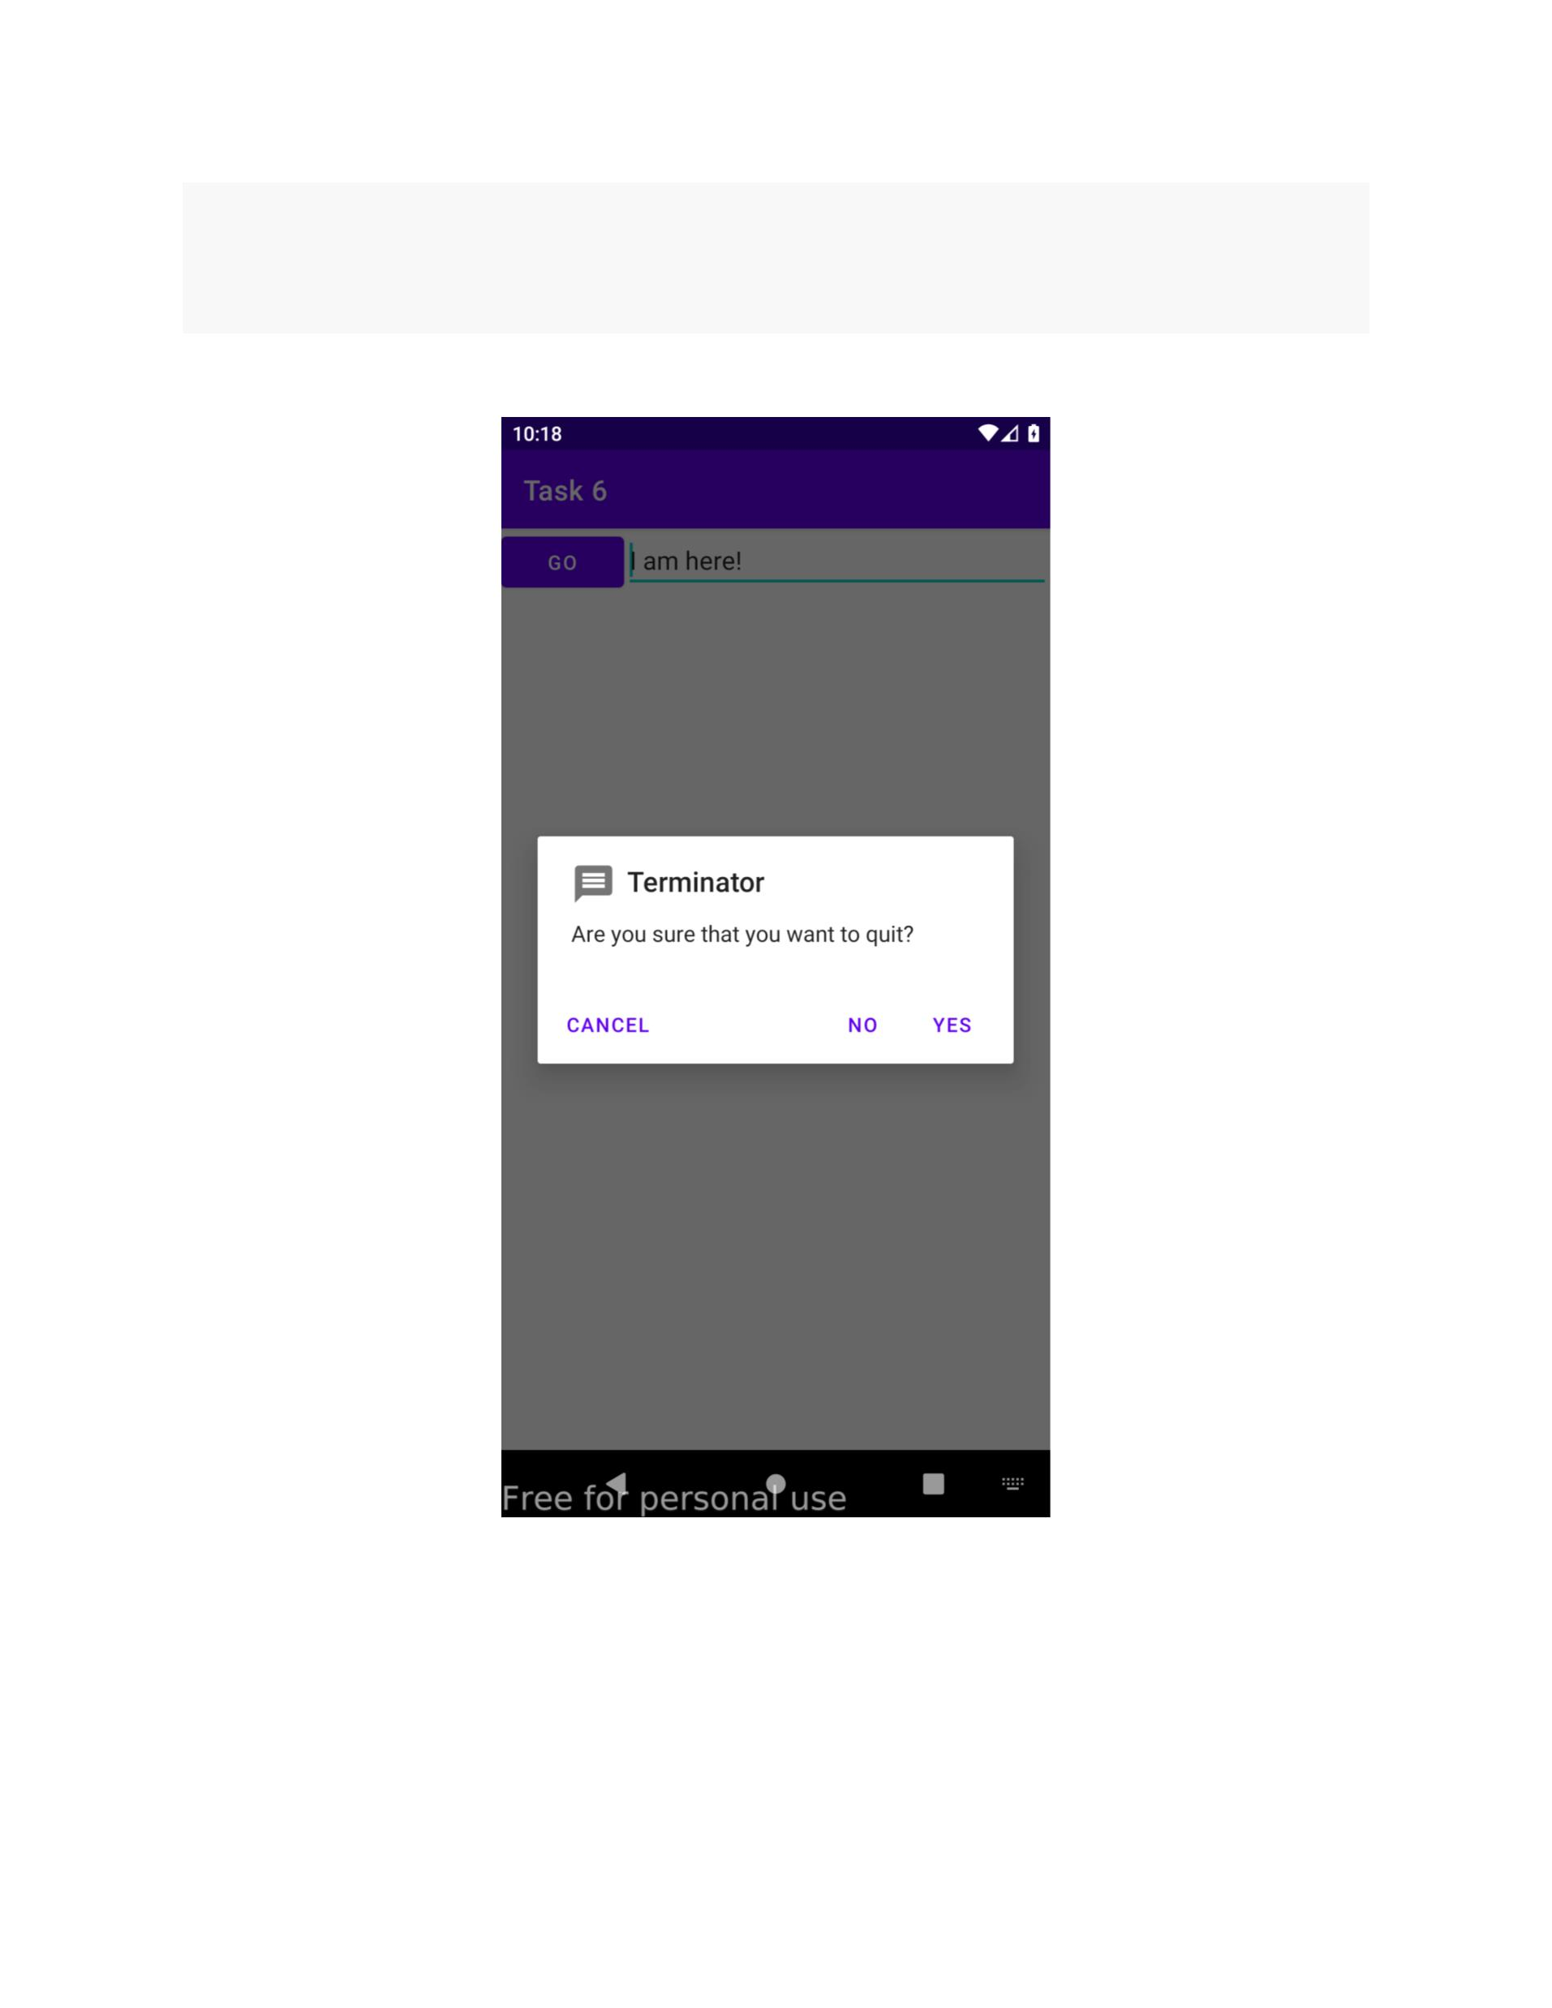

return myQuittingDialogBox;

}// createDialogBox

}

**Screenshot:**

**Toast Demo 1**

**Code:**

*activity_toast_demo_1.xml*

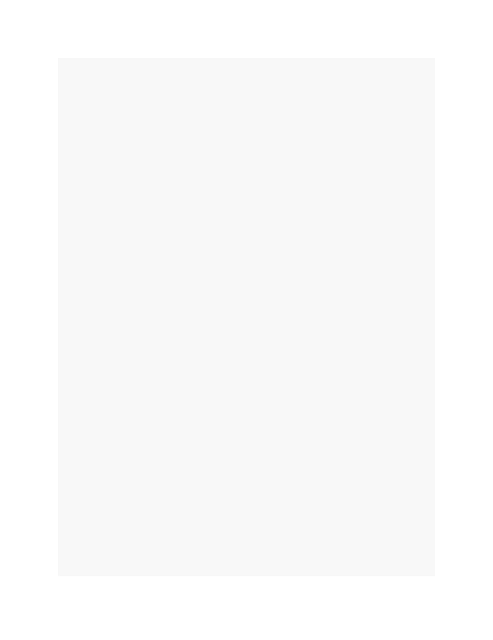

**<?**xml version="1.0" encoding="utf-8"**?>**

<TableLayout

xmlns:android="http://schemas.android.com/apk/res/android"

android:id="@+id/myTableLayout"

android:layout_width="fill_parent"

android:layout_height="fill_parent"

android:background="#ff0000ff"

android:orientation="vertical"

android:stretchColumns="1,2">

<TableRow

android:id="@+id/myRow0"

android:layout_width="fill_parent"

android:layout_height="wrap_content"

android:orientation="horizontal">

<TextView

android:id="@+id/myCaption"

android:layout_width="fill_parent"

android:layout_height="wrap_content"

android:layout_span="2"

android:background="#ff009999"

android:gravity="center"

android:text="Testing Toast - Gravity.CENTER 320x480

pixels"

android:textSize="20sp"></TextView>

</TableRow>

<TableRow

android:id="@+id/myRow1"

android:layout_width="fill_parent"

android:layout_height="wrap_content"

android:background="#ff0000ff"

android:orientation="horizontal"

android:padding="10px">

<TextView

android:id="@+id/xLabel"

android:layout_width="wrap_content"

android:layout_height="wrap_content"

android:text=" X offset: "

android:textSize="18sp"></TextView>

<EditText

android:id="@+id/xBox"

android:layout_width="wrap_content"

android:layout_height="wrap_content"

android:inputType="numberSigned"

android:text="0"

android:textSize="18sp"></EditText>

</TableRow>

<TableRow

android:id="@+id/myRow2"

android:layout_width="fill_parent"

android:layout_height="wrap_content"

android:background="#ff0000ff"

android:orientation="horizontal"

android:padding="10px">

<TextView

android:id="@+id/yLabel"

android:layout_width="wrap_content"

android:layout_height="wrap_content"

android:text=" Y offset: "

android:textSize="18sp"></TextView>

<EditText

android:id="@+id/yBox"

android:layout_width="wrap_content"

android:layout_height="wrap_content"

android:inputType="numberSigned"

android:text="0"

android:textSize="18sp"></EditText>

</TableRow>

<TableRow

android:id="@+id/myRow3"

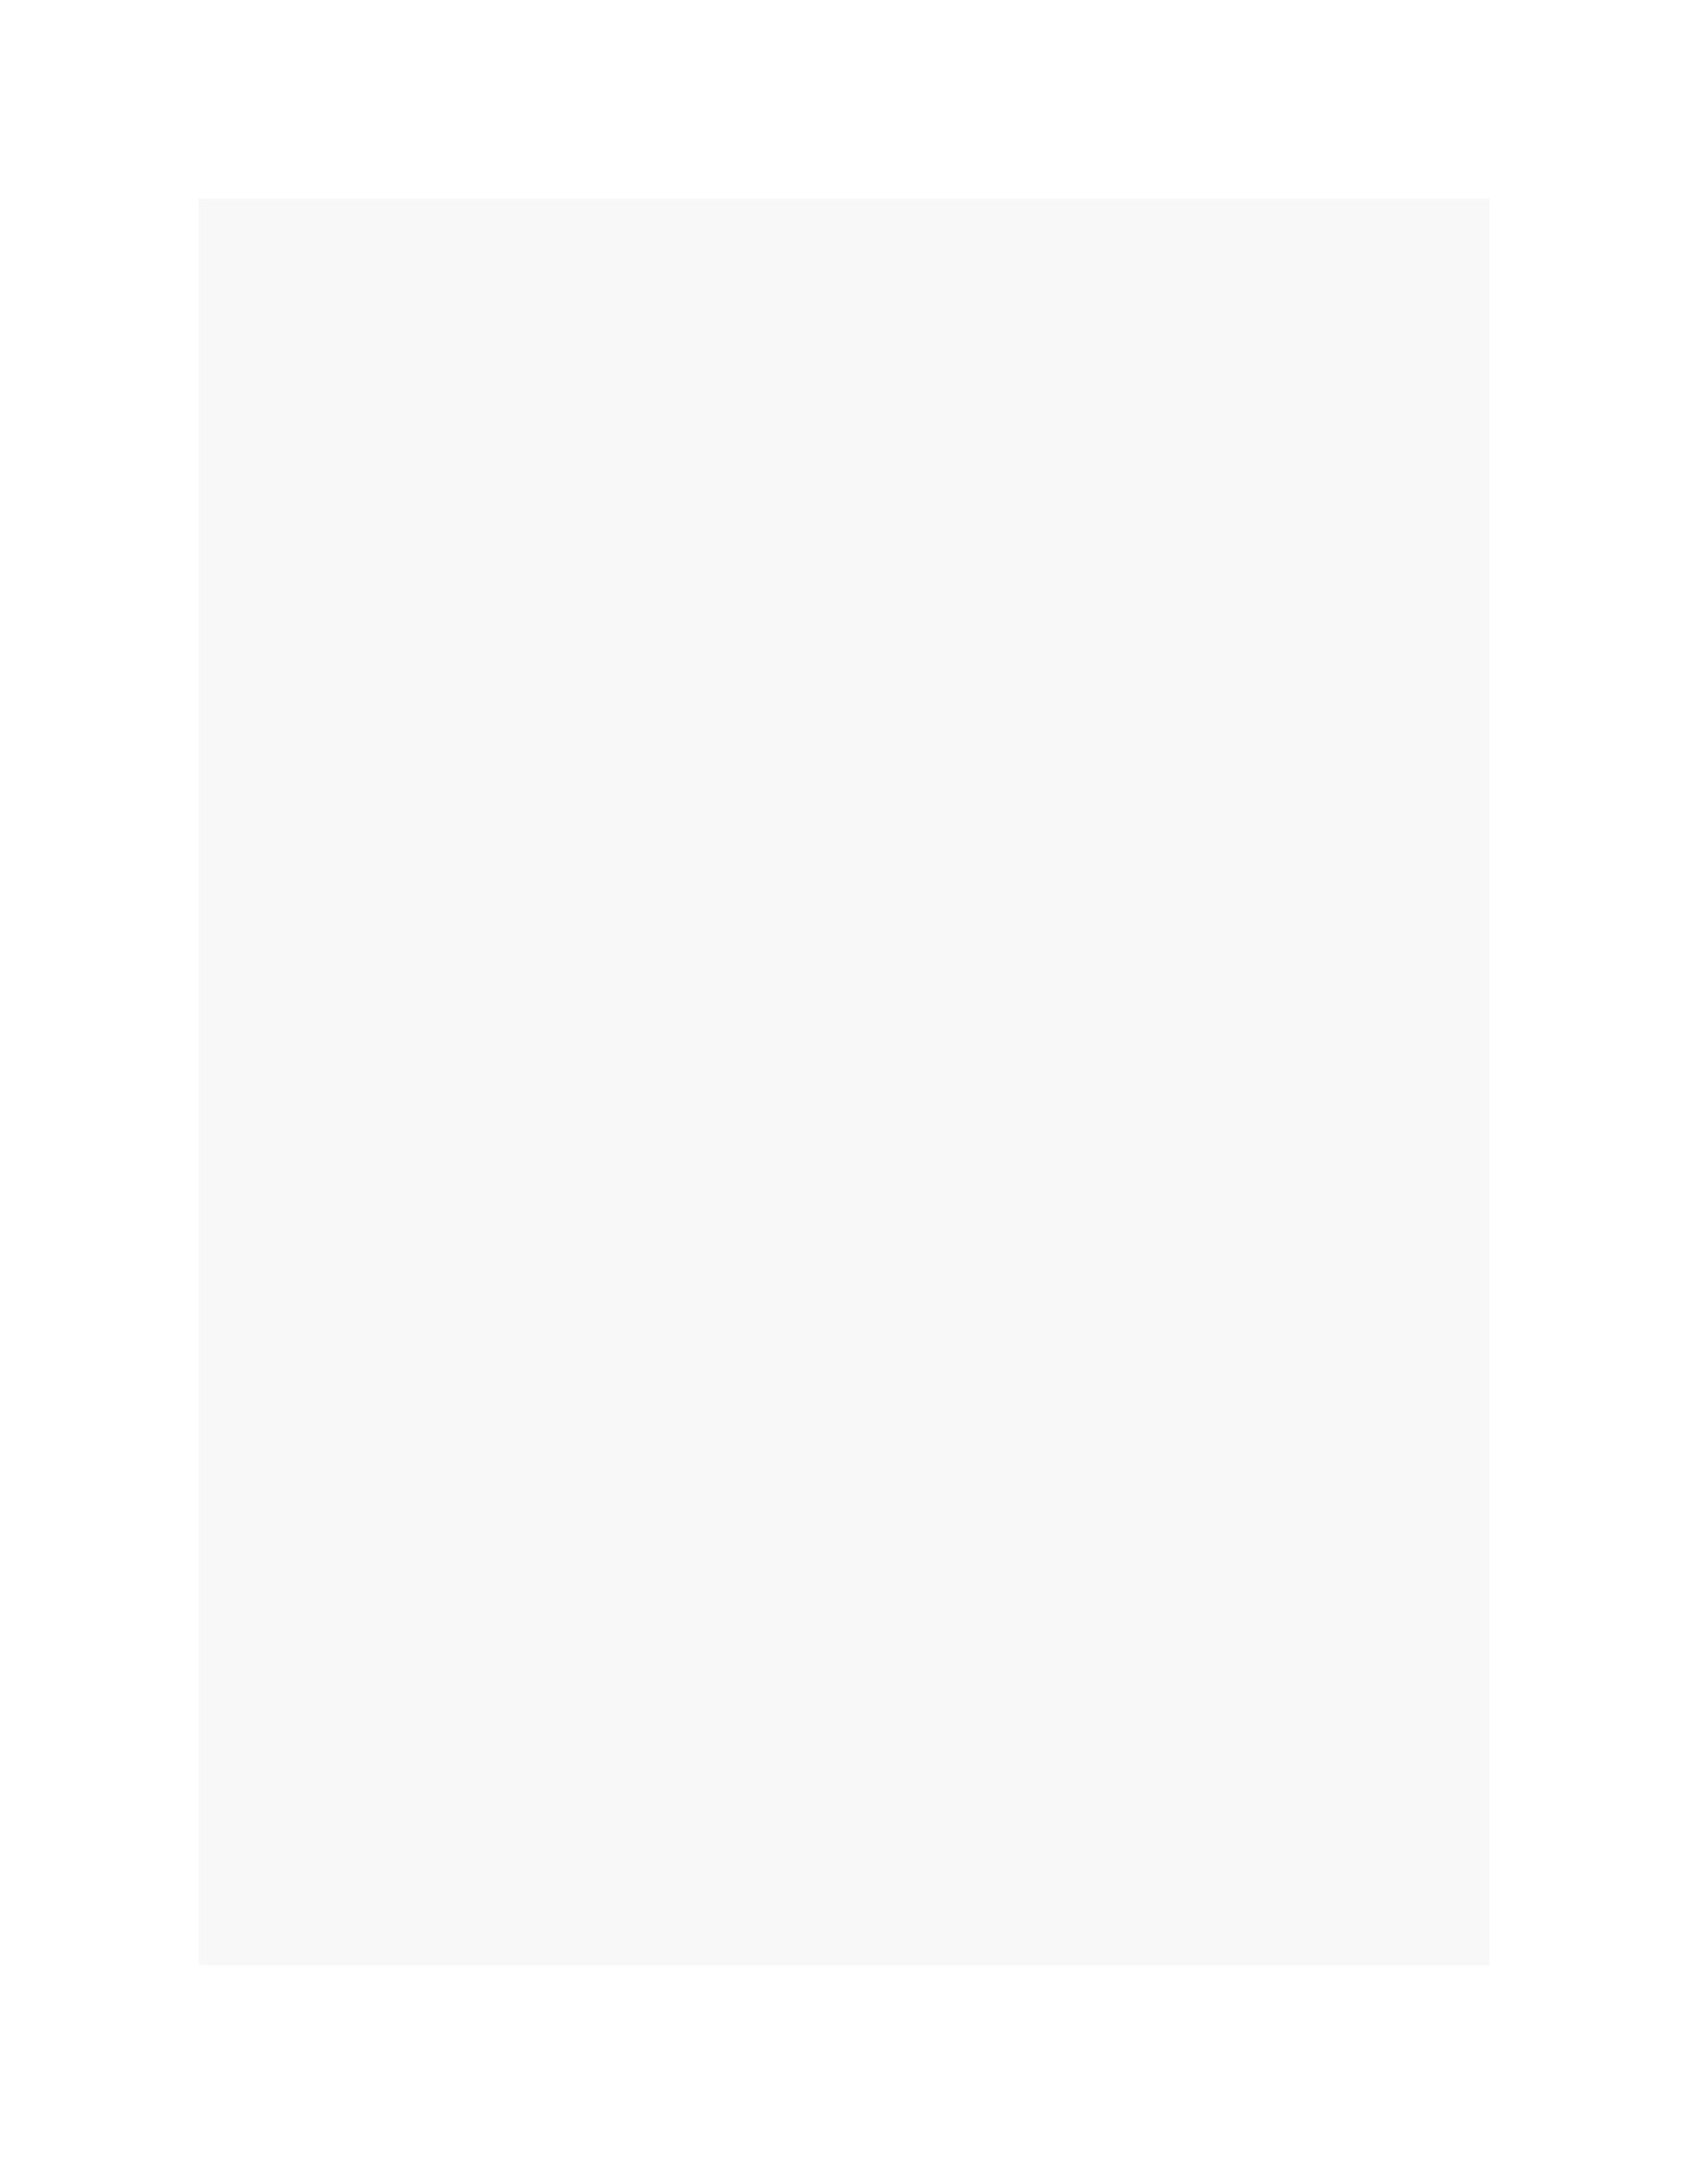

android:layout_width="fill_parent"

android:layout_height="wrap_content"

android:background="#ff0000ff"

android:orientation="horizontal"

android:padding="10px">

<Button

android:id="@+id/btn1"

android:layout_width="wrap_content"

android:layout_height="wrap_content"

android:layout_span="2"

android:text=" Show Toast "></Button>

</TableRow>

</TableLayout>

*ToastDemo1.java*

**public** **class** **ToastDemo1** **extends** **AppCompatActivity** {

EditText xBox;

EditText yBox;

Button btn1;

**@Override**

**protected** **void** **onCreate**(Bundle savedInstanceState) {

**super**.onCreate(savedInstanceState);

setContentView(R.layout.activity_toast_demo1);

xBox = (EditText) findViewById(R.id.xBox);

yBox = (EditText) findViewById(R.id.yBox);

btn1 = (Button) findViewById(R.id.btn1);

*// onClick*

btn1.setOnClickListener(v -> {

**try** {

Toast myToast = Toast.makeText(

getApplicationContext(),

"Saludos amigos \n Hasta la vista",

Toast.LENGTH_LONG);

myToast.setGravity(Gravity.CENTER,

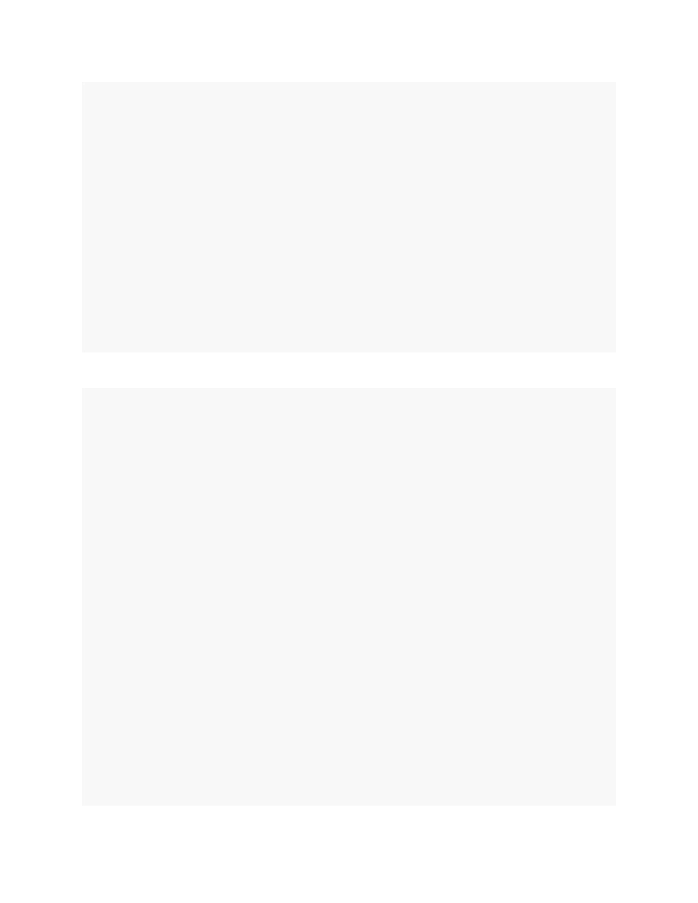

Integer.valueOf(xBox.getText().toString()),

Integer.valueOf(yBox.getText().toString()));

myToast.show();

} **catch** (NumberFormatException e) {

Toast.makeText(getApplicationContext(),

e.getMessage(),

Toast.LENGTH_LONG).show();

}

}); *// listener*

}

}

**Screenshot:**

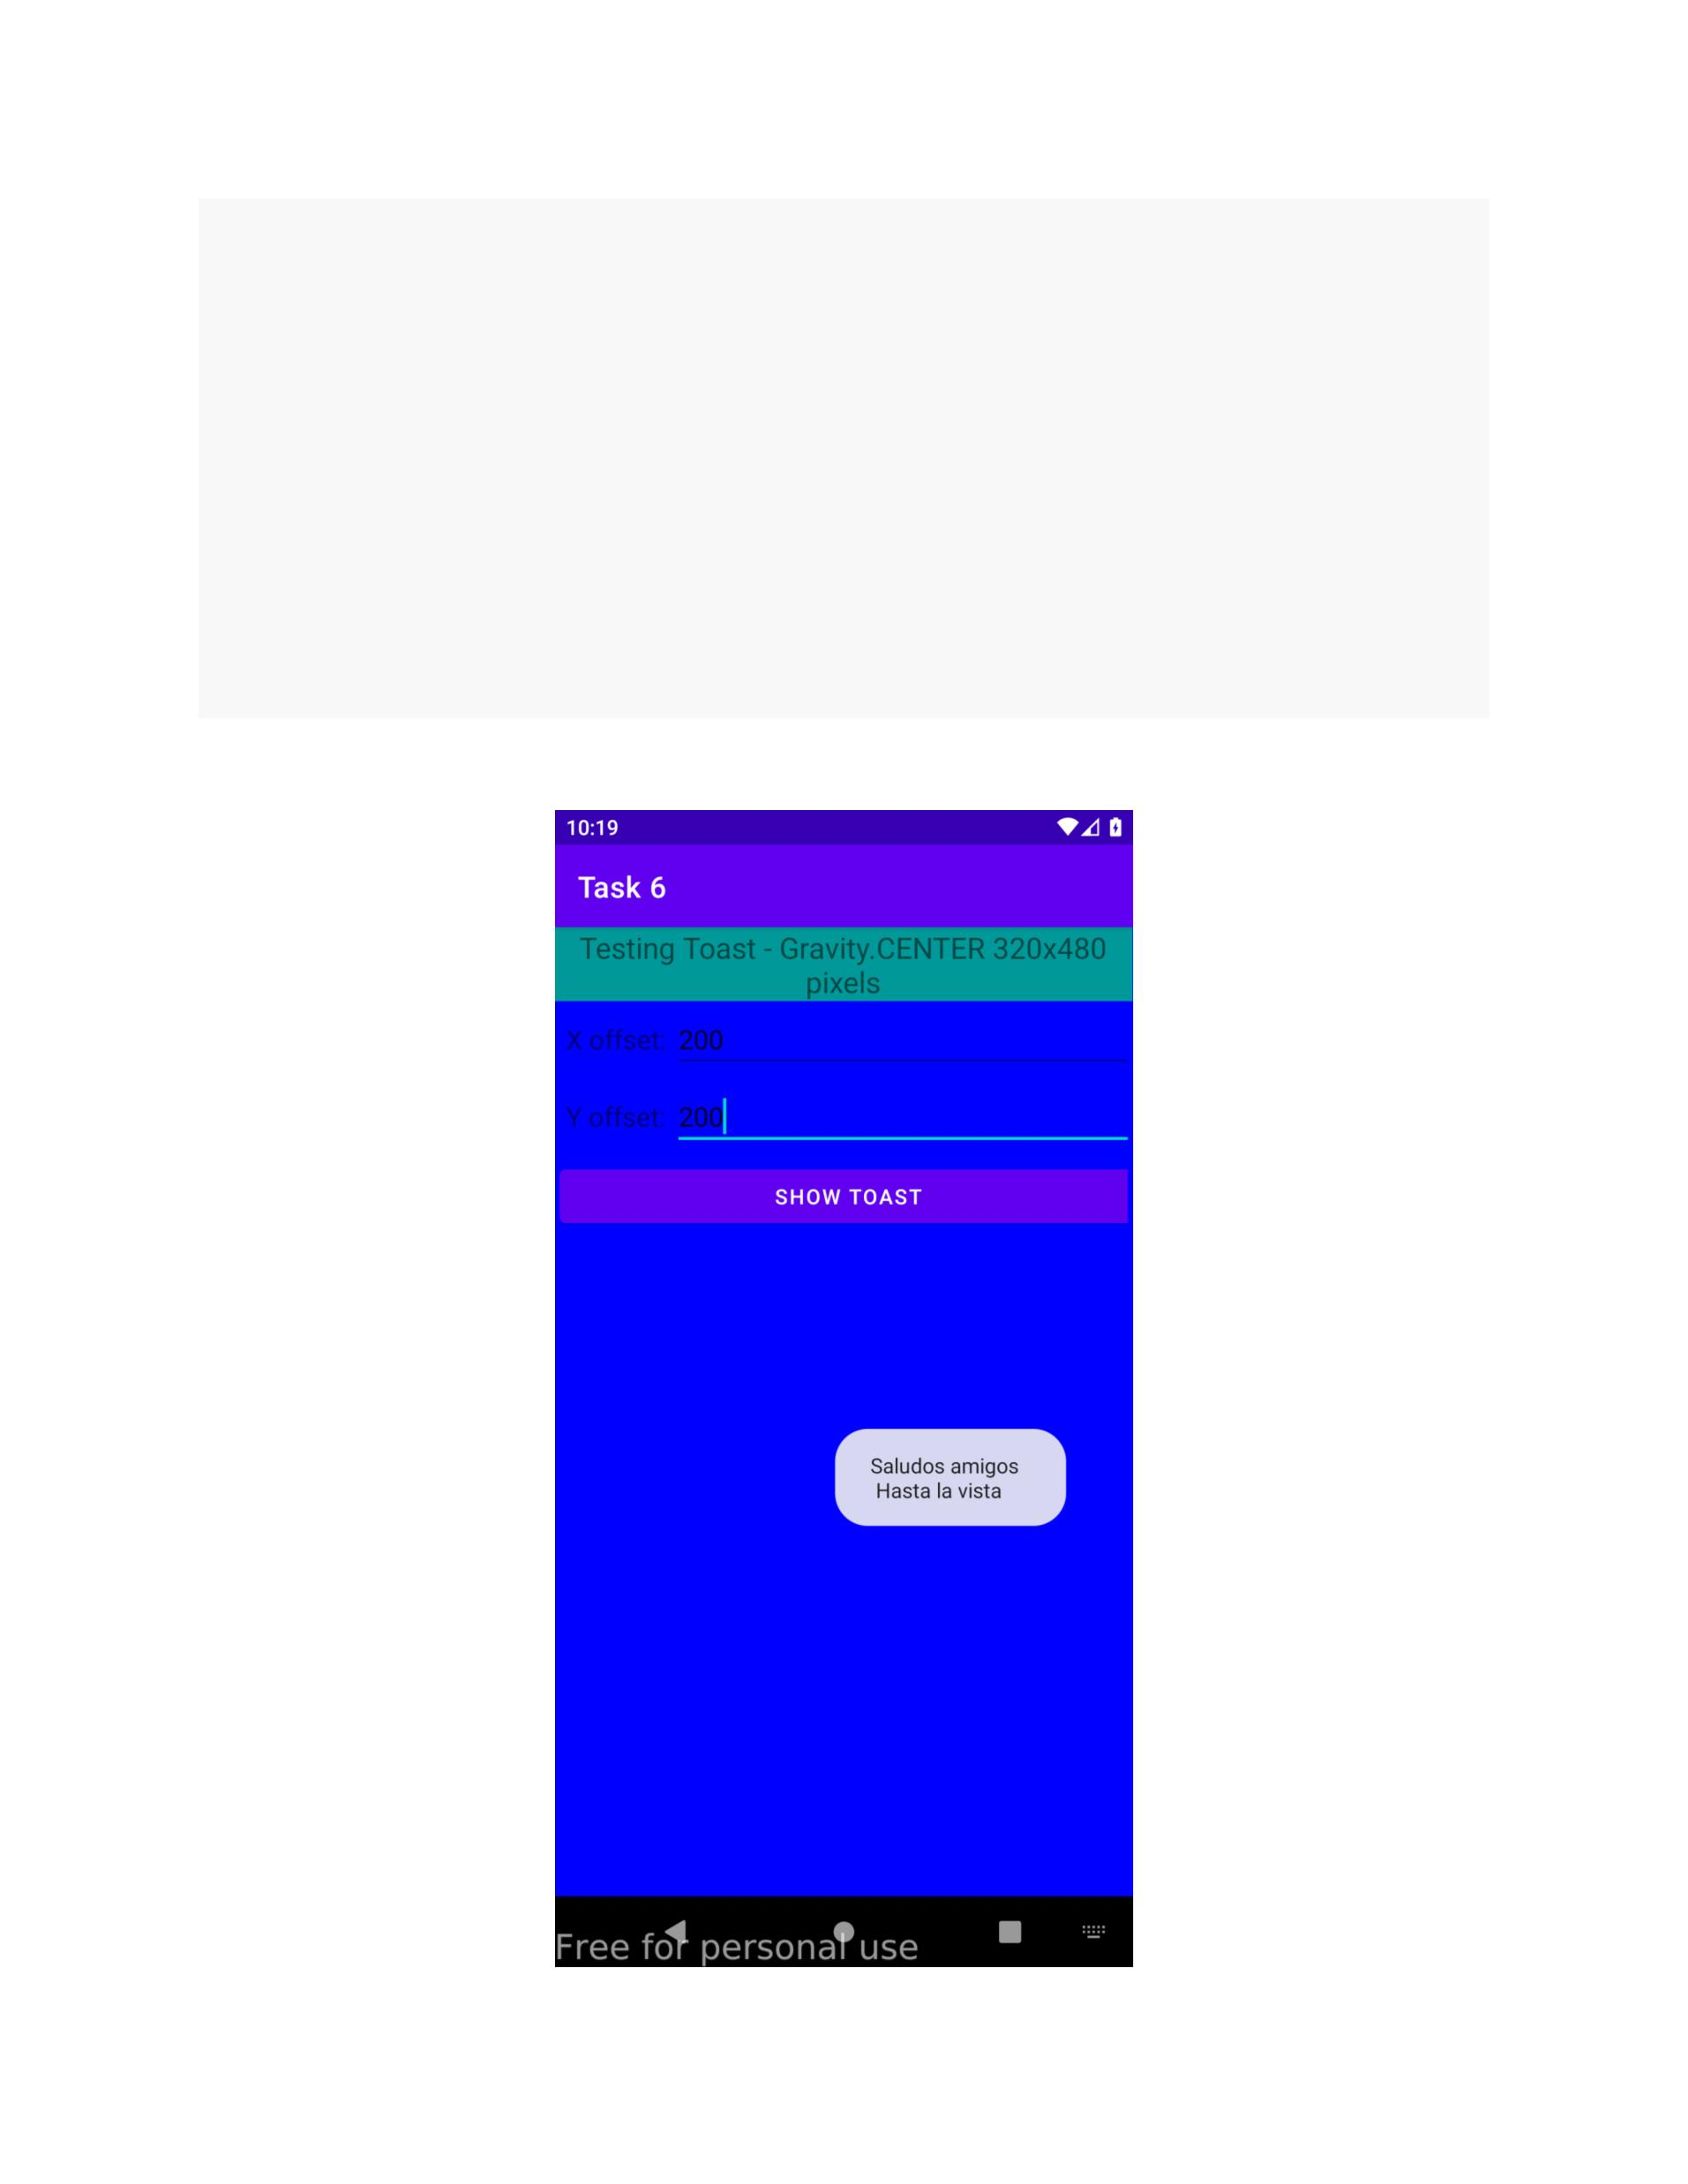

**Toast Demo 2**

**Code:**

*Activity_toast_demo_2.xml*

**<?**xml version="1.0" encoding="utf-8"**?>**

<TableLayout

xmlns:android="http://schemas.android.com/apk/res/android"

android:id="@+id/myTableLayout"

android:layout_width="fill_parent"

android:layout_height="fill_parent"

android:background="#ff0000ff"

android:orientation="vertical"

android:stretchColumns="1,2">

<TableRow

android:id="@+id/myRow0"

android:layout_width="fill_parent"

android:layout_height="wrap_content"

android:orientation="horizontal">

<TextView

android:id="@+id/myCaption"

android:layout_width="fill_parent"

android:layout_height="wrap_content"

android:layout_span="2"

android:background="#ff009999"

android:gravity="center"

android:text="Testing Toast - Gravity.CENTER 320x480

pixels"

android:textSize="20sp"></TextView>

</TableRow>

<TableRow

android:id="@+id/myRow1"

android:layout_width="fill_parent"

android:layout_height="wrap_content"

android:background="#ff0000ff"

android:orientation="horizontal"

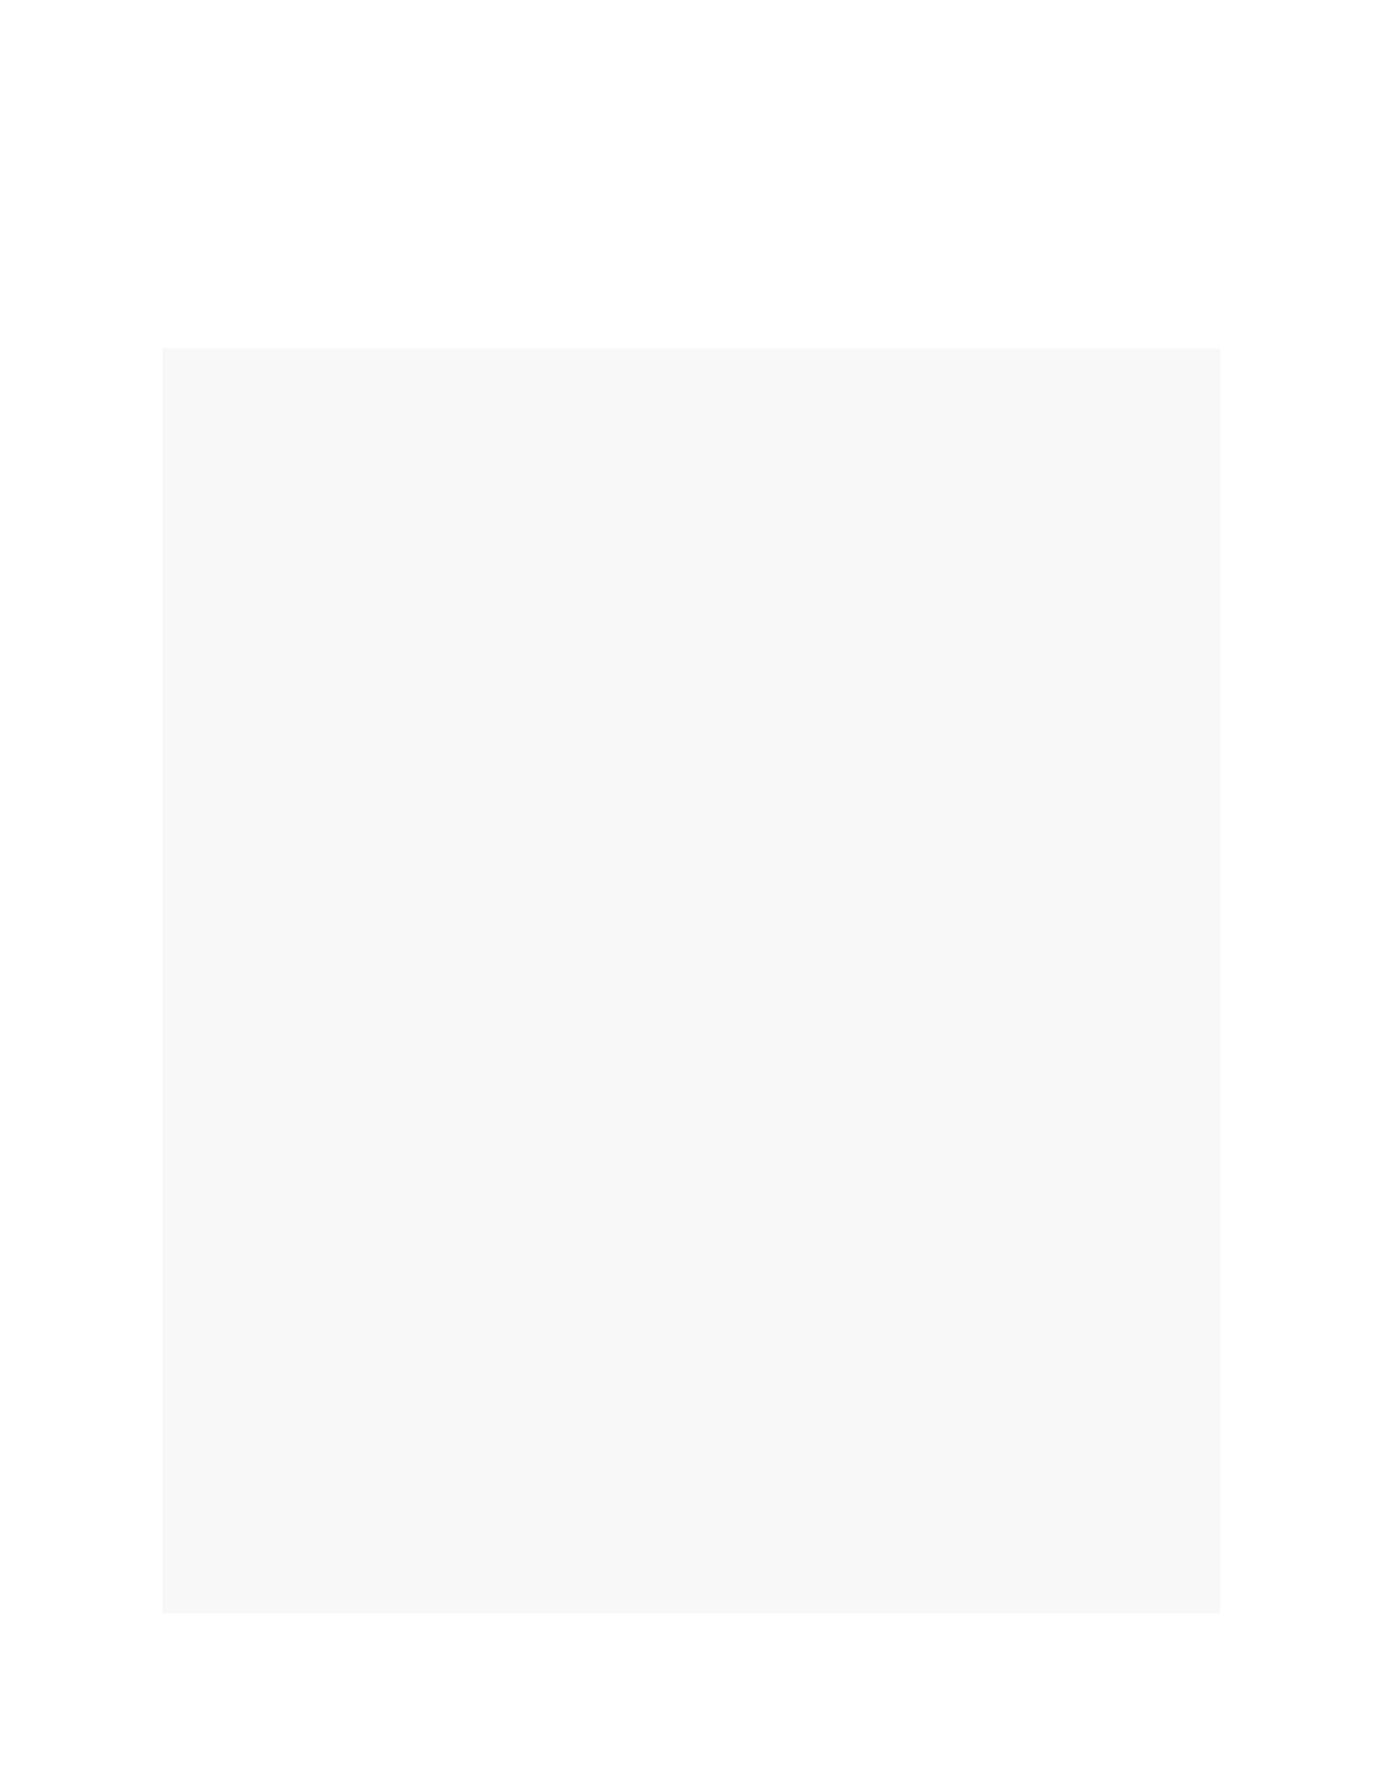

android:padding="10px">

<TextView

android:id="@+id/xLabel"

android:layout_width="wrap_content"

android:layout_height="wrap_content"

android:text=" X offset: "

android:textSize="18sp"></TextView>

<EditText

android:id="@+id/xBox"

android:layout_width="wrap_content"

android:layout_height="wrap_content"

android:inputType="numberSigned"

android:text="0"

android:textSize="18sp"></EditText>

</TableRow>

<TableRow

android:id="@+id/myRow2"

android:layout_width="fill_parent"

android:layout_height="wrap_content"

android:background="#ff0000ff"

android:orientation="horizontal"

android:padding="10px">

<TextView

android:id="@+id/yLabel"

android:layout_width="wrap_content"

android:layout_height="wrap_content"

android:text=" Y offset: "

android:textSize="18sp"></TextView>

<EditText

android:id="@+id/yBox"

android:layout_width="wrap_content"

android:layout_height="wrap_content"

android:inputType="numberSigned"

android:text="0"

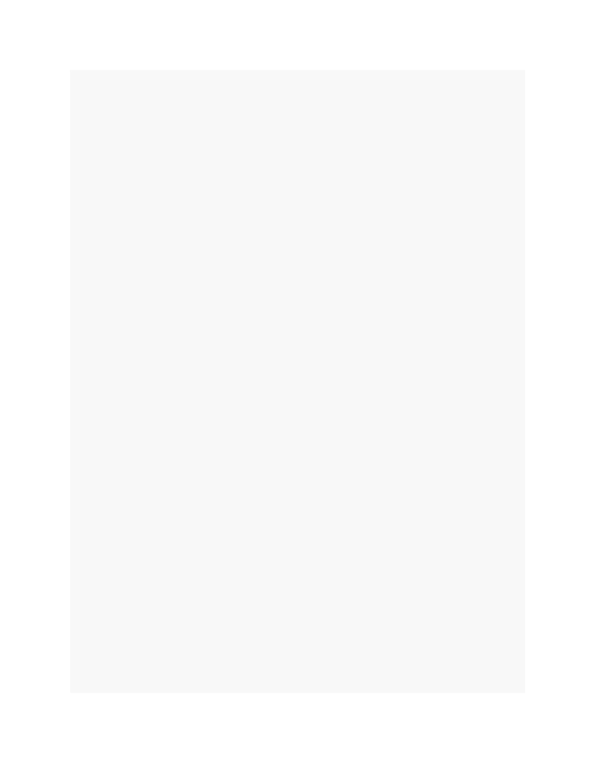

android:textSize="18sp"></EditText>

</TableRow>

<TableRow

android:id="@+id/myRow3"

android:layout_width="fill_parent"

android:layout_height="wrap_content"

android:background="#ff0000ff"

android:orientation="horizontal"

android:padding="10px">

<Button

android:id="@+id/btnShowToast"

android:layout_width="wrap_content"

android:layout_height="wrap_content"

android:layout_span="2"

android:text=" Show Toast "></Button>

</TableRow>

</TableLayout>

*my_toast_layout.xml*

**<?**xml version="1.0" encoding="utf-8"**?>**

<LinearLayout

xmlns:android="http://schemas.android.com/apk/res/android"

android:id="@+id/my_toast_layout_root"

android:layout_width="fill_parent"

android:layout_height="fill_parent"

android:orientation="horizontal"

android:padding="10dp">

<TextView

android:id="@+id/text"

android:layout_width="wrap_content"

android:layout_height="wrap_content"

android:padding="20dp"

android:background="@drawable/my_border"

>

</TextView></LinearLayout>

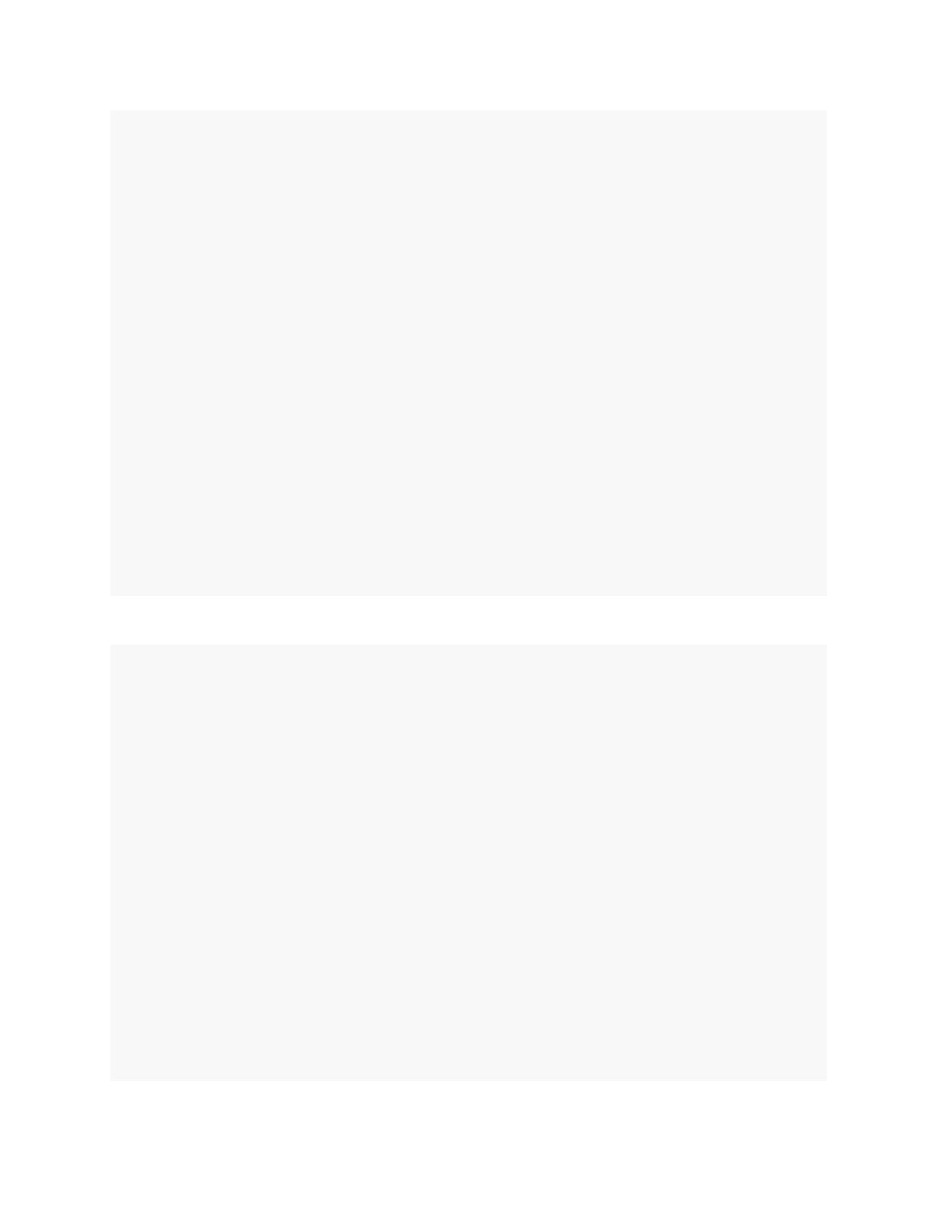

*my_border.xml*

**<?**xml version="1.0" encoding="UTF-8" **?>**

<shape xmlns:android="http://schemas.android.com/apk/res/android"

android:shape="rectangle">

<stroke

android:width="2dp"

android:color="#ffffff00" />

<stroke

android:width="2dp"

android:color="#ffffff00" />

<solid android:color="#ff990000" />

<padding

android:bottom="4dp"

android:left="10dp"

android:right="10dp"

android:top="4dp" />

<corners android:radius="15dp" />

</shape>

*ToastDemo2.java*

**public** **class** **ToastDemo2** **extends** **AppCompatActivity** {

**@Override**

**protected** **void** **onCreate**(Bundle savedInstanceState) {

**super**.onCreate(savedInstanceState);

setContentView(R.layout.activity_toast_demo2);

Button btnShowToast = (Button)

findViewById(R.id.btnShowToast);

btnShowToast.setOnClickListener(v -> {

LayoutInflater inflater = getLayoutInflater();

View layout = inflater.inflate(

R.layout.my_toast_layout,

(ViewGroup)

findViewById(R.id.my_toast_layout_root));

TextView text = (TextView) layout.findViewById(R.id.text);

Toast toast = **new** Toast(getApplicationContext());

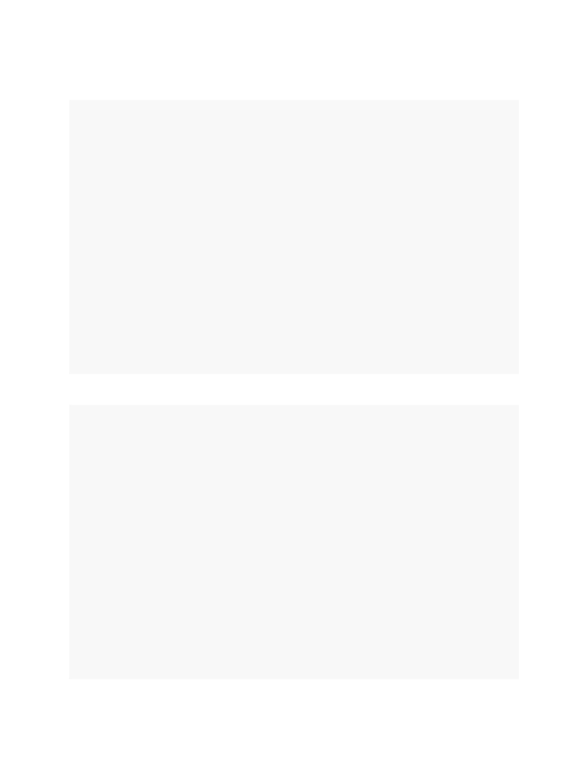

text.setText("Hola mundo \nI'm a fancy Toast");

toast.setGravity(Gravity.CENTER, 0, 0);

toast.setDuration(Toast.LENGTH_SHORT);

toast.setView(layout);

toast.show();

Toast.makeText(getApplicationContext(),

"Hola mundo \nnow I am quite normal",

Toast.LENGTH_SHORT).show();

});

}

}

**Screenshot:**

